**Newsletter June 2019**

**Contents**

* Our lecture series - report
* A group of people sitting at a table

  Description generated with very high confidenceDetails of other lectures to come this year
* Regional meeting of the IAWJ in Madrid in April 2019 – report
* Women in Criminal Law in the Midlands WICL – wellbeing event report
* ILBA launch report on bullying in the legal profession
* 1st 100 years – walks and podcasts
* Association of Women Barristers summer drinks
* Dates for our annual conference
* IAWJ conference in 2020

**Celebrating 100 years of women in the legal profession – AWJ lecture series**

**8th May 2019 at Oxford**

**“Sexual harassment at work, unacceptable, unlawful but unremitting – reflections on its nature and persistence and on the changing legal landscape”.**

The second in the series of events promoted by the UK Association of Women Judges to celebrate 100 years of women in the legal profession took place in Oxford on 8 May under the above title The panellists were our former vice-president, Dame Laura Cox and Oxford academic, Professor Sandra Fredman. The session was moderated by Employment Appeal Tribunal Judge, Her Honour Judge Jennifer Eady.

Women are still subordinated at work and there is a need to address why it remains so tireless and unyielding a problem. The “Me Too” movement shone a light on the world of celebrity and brought the issue of sexual harassment in the workplace to public prominence. The reports by the TUC, Fawcett Society, and the Equality and Human Rights Commission highlighted the significant problems encountered with sexual harassment.

The courage of those challenging discrimination, in campaigning, seeking changes in legislation or pursuing individual complaints is central to addressing the issue. Sexual harassment has been unlawful since 1986 and yet it remains ever present in the workplace. It hampers efforts to advance gender equality, sours working relationships and stifles women’s potential. An obligation on employers to provide a workplace where people know such behaviour is not acceptable would be a start.

One answer would be to restore some of the protections such as an employer’s responsibility for the actions of third parties and the power of the Tribunal to make recommendations about the practices of the employer. The process of bringing a claim needs to be fair both to the complainant and the person responding to the allegation.

This is not just a women’s issue. Men who are in senior positions can make a difference. The ILO has now agreed a convention on violence and harassment in the world of work to be adopted later this year which has the prospect of getting to the heart of the problem because each member state will have to report on how all workers are protected.

Speakers about sexual harassment

Description generated with very high confidence

The speakers and Nomfundo Ramalekana who introduced the event

The evening served as a reminder that we cannot be complacent and must continue to remain vigilant in protecting the rights of workers not to be subjected to sexual harassment at work.

This event would not have taken place without the support and involvement of the University of Oxford Faculty of Law and the Oxford Human Rights Hub and we are also extremely grateful to Cloisters chambers who sponsored the drinks reception.

– here is the video to watch

<https://www.youtube.com/watch?v=4IAezKvYDGQ&feature=youtu.be>

Report from Margaret Glentworth – thanks

A picture containing athletic game

Description generated with high confidence

**Justice with a gender perspective**

Hosted by the Association of Women Judges of Spain (AMJE), the 2019 Europe, Middle East and North Africa Conference of the IAWJ took place in Madrid on April 25 and 26. Howeve,r probably to the surprise but delight of the participants, the event was an International Congress attended by around 400 mainly women judges from 35 different countries with a particularly large contingent from Argentina supporting the IAWJ President Vanessa Ruiz.

The conference theme was “Justice with a gender perspective” and over the course of 2 days, the first being a marathon 9 hours. We heard from around 50 different speakers who looked at judging with a gender perspective in criminal, social, civil, and administrative jurisdictions and also the legal profession, prosecution, forensic and other levels of justice, women and homeless minors.

What rapidly emerged from the opening session was how much we share in common as women in our respective jurisdictions. We are familiar with glass ceilings and sticky floors for women but it was interesting if rather disappointing to hear that invariably colleagues from around the world share these barriers and also to hear of glass elevators for men and for women a glass corridor to a classroom or cage. However spirits were not dampened and the exchange of knowledge is invaluable.Speaker in Madrid

Description generated with very high confidence

Some presentations overlapped the theme of judging with a gender perspective in specific jurisdictions with general gender issues in their geographical jurisdiction. There were interesting insights on how they address the issues and the outcomes of having a gender perspective in approach.

As an example, Spanish judges include gender training in all courses in the criminal courts and there is attention to terminology. Taking account of a high rate of gender-based violence, gender-based aggravating factors can be applied to any attack not just in the context of domestic relationships. There is no need to prove an intention to dominate, this is considered implicit by the act of violence. Prior to 1976 women could not be judges in Spain however in the administrative court there is a quota for one third of judges to be female. The first woman judge was appointed in 1981 and within this relatively short period of time women have been appointed to the Supreme Court.

In Libya the issue is implementing non-discriminatory or protective laws and measures some of which positively favour men and the obstacles that women face in accessing positions of authority. We heard of the practical problems of administering justice in a country such as Libya which is in in the midst of a humanitarian crisis. This extends to courts and other institutions forced to cease functioning during times of war.

In Tunisia, where the first woman judge was appointed in 1968, we heard that there are many women in public administration but again they face a glass ceiling. Similar to our own jurisdiction there is an increase at first tier level in the criminal and administrative courts with a total of 38% female judges however there is lack of access to senior positions. Whilst there are issues such as lack of availability of maternity leave that impacts on seniority, there is also an element of self-exclusion due to the added responsibility of senior roles and issues of personal security. However the position of women at all levels of the judiciary was being addressed by legislation.

From the UK, we had an update from Scotland which included positive action as distinct from positive discrimination measures to ensure full equality in practice. There was reference to recent legislation; the Gender Representation on Public Boards (Scotland) Act 2018 and the use of European Court of Human Rights (ECHR) case law in addressing inequality and violence against women. In the case of Eremia and Others v Moldova (Application No. 3564/11), the ECHR recognised the gender discriminatory aspect of domestic violence against women and confirmed the possibility of characterising domestic violence as inhuman treatment within the meaning of Article 3 ECHR. Although a signatory to the Council of Europe Convention on preventing and combating violence against women and domestic violence which includes definitions for violence against women and gender based violence et al, the UK has failed to ratify the Convention.

A more positive picture and perhaps surprising given the rather robust pronouncements of the Filipino President, the Philippines appeared to be one of the most progressive jurisdictions. We were told that in pay and education women outperform men and the Philippines is in the world top 10 in terms of gender parity although this does not yet extend to women owning land, or as elected officials. This progress has been underpinned by various frameworks and legislation including a women in development and nation building and a Magna Carta for women. There is specific legislation that protects women such as Anti-sexual harassment Act, Antirape law, Rape Victims Assistance and Protection Act, Antitrafficking in Persons Act and Anti -Violence Against Women and TheirCchildren Act. The specific issue of women not holding land might be remedied by proposed agrarian reform law.

Speaker at Madrid conference

Description generated with very high confidenceBack to the general programme, in civil jurisdiction, the specific topics considered were the more familiar issues of the family including separation, divorce, custody and surnames registration. The forensic medicine aspect looked at how applying a gender perspective might determine the way in which an investigation is conducted. The data shows that the homicide rate worldwide is falling but the rate of femicide has flatlined. This has led to the development of a Latin American protocol model to determine femicide which provides for femicide always being considered in cases of female homicide taking into consideration what is known of the victim, their family relationships as well as the type of wounds.

This piece just touches a few of the presentations. The conference also included a video projection entitled “Educating in equal justice” which showed Spanish college students role-playing a court room hearing having regard to gender challenging societal stereotypical thinking and bias. There was another interesting video and oral presentation by “Women’s Link Worldwide” on the Mmyth of Judicial Neutrality” which looked at gender balanced leadership. Although it focused on the corporate world the issues are equally relevant in our respective jurisdictions. This organisation is pushing for quota regulations backed up by hard sanctions.

One of the judges from Libya had made a number of interventions during the conference asking for support for women in her jurisdiction. The sense of how much women in the judiciary worldwide share issues in common was brought home in her final intervention at the end of the conference when she said she took some comfort having heard from Upper Tribunal Judge Gleeson on the gender disparities in the UK judiciary, particularly in senior posts. A sobering reflection of our justice system.

But all work and no play makes Jill a dull girl. AMJE were excellent hosts and many of us enjoyed a memorable evening at La Favorita restaurant located in a beautiful old house in central Madrid where some of the waiting staff and music students delighted us with well-known opera arias between courses.

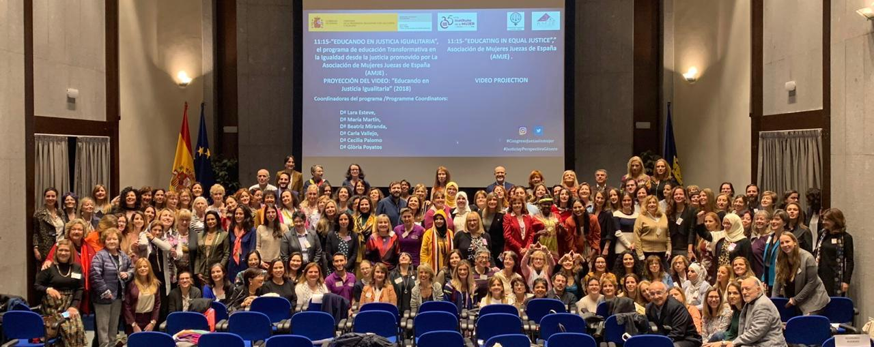

Thanks also to Anisa Dhanji for tracking down and arranging dinner at Botín Restaurant, said to have been founded in 1725 and according to the Guinness Book of Records is the oldest restaurant in the world. A fine ending to a truly uplifting, but intense and rewarding conference which was also a great opportunity to network, meet old friends and make new ones.

Cordella Bart-Stewart

**A close up of a logo

Description generated with very high confidence– further lectures in the Associations lecture series celebrating 100 years of women in law**

On **16 October at the London School of Economics,** Professor Emily Jackson will be in discussion with Mrs Justice Lucy Theis and barrister and Deputy High Court Judge Deirdre Fottrell QC on the topic of women’s reproductive rights.

Later in the autumn, at Edinburgh University, Professor Sharon Cowan and the Honourable Lady Margaret Scott will examine substantive Scottish criminal law and its treatment of women, looking at the reform of the law on diminished responsibility for women who have been abused and the still-existing common law plea of provocation based on infidelity. They also hope to touch on some other areas where reform is needed.

The year of talks will end with a session called ‘Women judges and academics in conversation about key cases’. This will reflect Feminist Judgments projects, including a book in the UK edited by Hunter, McGlynn and Rackley. There are now projects around the world in which important legal decisions are re-examined from the point of view of gender justice.

**MARK YOUR DIARY !**

**UKAWJ Annual conference** – is to take place on Friday 8th November 2019 at the Parke Plaza Hotel in Birmingham – for salaried judges this is official business. Our theme is “Migration, Slavery and the Law and a range of fascinating speakers are being lined up. On Thursday night there is a dinner and Brenda Hale – our founding President – will be our after dinner speaker.

**2020 plans for New Zealand**

**Confernece flyer

Description generated with high confidence**

**IAWJ's 15th Biennial Conference**: "Celebrating Diversity" will be hosted by the New Zealand Association of Women Judges (NZAWJ) in Auckland, Aotearoa, New Zealand from May 7 - 10, 2020.

We will be letting you know of proposed trips you can engage in if you choose to make this long journey – many of our members do plan to go

First 100 years

Guided Walks

This year marks the centenary for women being allowed to join the legal profession following the passing of the Sex Disqualification (Removal) Act 1919.

To celebrate this landmark, the First 100 years project and [Walk London With Us](https://walklondonwithus.com/) have created the first guided walk of the key locations significant to the lives of many of the pioneering and truly remarkable women in the law then and now.

The tour will include the four Inns of Court, Chancery Lane, the Law Society, the Royal Courts of Justice and other fascinating places with stories to tell about the lives of some of the ‘firsts’ including some from the present day.

The walk will begin at Chancery Lane Station, Exit 1 (outside on the pavement next to the Robert Dyas shop) and will end at Middle Temple, near Temple station. It will last about two hours.

To book tickets go to [www.eventbrite.co.uk/e/first-100-years-guided-walk-tickets-60817482728](http://www.eventbrite.co.uk/e/first-100-years-guided-walk-tickets-60817482728)

And listen to their podcasts- available at all suppliers

[Trailer](https://first100years.org.uk/podcast-trailer/)

[The First Decade: 1919 – 1929 ‘A sacred year or a dead letter?’](https://first100years.org.uk/episode-1-1919-1929/)

[The Second Decade: 1929 – 1939 ‘The ‘Firsts’: Gaining a Foothold’](https://first100years.org.uk/the-second-decade-1929-1939/)

[The Third Decade: 1939 – 1949: ‘Sitting in Judgment: Women Magistrates and Jurors’](https://first100years.org.uk/the-third-decade-1939-1949/)

[The Fourth Decade: 1949 – 1959: Hostile Culture](https://first100years.org.uk/the-fourth-decade-1949-1959/)

The Fifth Decade: 1959 – 1969: My Lord Becomes My Lady

See below for blog from oxford law hub

http://ohrh.law.ox.ac.uk/the-entry-of-women-into-the-legal-profession-under-british-colonial-rule/

A close up of text on a white background

Description generated with very high confidence

**Walk with WICL**

On 17th June 2019 - WICL will be joining over 700 other teams taking part in the London Legal Walk in support of The London Legal Support Trust.

WICL hope to have a strong walking presence amongst the hundreds of different organisations, firms and chambers so please join them if you can.

.

If you would like to join , we will be meeting outside The Law Society,

113 Chancery Lane from 5pm, ready to set off at 5:30pm.

(Look out for our balloons to find us!)

Please RSVP to wicl@gmail.com by 10th June 2019.mm

**28th May WICL Leicester University – Wellbeing event**

[Midlandswicl@gmail.com](mailto:Midlandswicl@gmail.com)

Over fifty local female Barristers, Solicitors, Legal Executives, Court Staff and Judiciary met at Leicester University for the Women in Criminal Law Midlands Wellbeing event. Women in Criminal Law Midlands is chaired by Michelle Heeley QC in the West Midlands and Leicester Barrister Mary Prior QC in the East Midlands. The event was co-hosted by 36Crime and the Midlands Asian Lawyers Association (MALA)

Mrs Justice Sue Carr DBE who is the Presiding Judge for the Midland Circuit gave a speech in which she recognised the stresses and strains on practitioners, Court users and the Judiciary of prosecuting and defending in cases of serious sexual offences. Dr Anna Carline and Dr Clare Gunby from Leicester University then presented their nationwide research “Exploring how emotions taint the work of rape barristers.” It became clear that barristers who conduct this work find it difficult to deal with the emotions it creates, particularly those who have children. There was a backlash from the public towards lawyers who defended people accused of sexual offences. This could be difficult to deal with. The workload was heavy and often it meant working late into the night which did not always fit in with family life. When Anna and Clare asked one lawyer how they felt the response was “Thank you for asking. No-one ever asks me that.”

District Judge Fayyaz Afzal OBE explained the commitment of MALA to the wellbeing of its members and explained how important it is for MALA to support its female members and try to encourage and support them to remain in practice within the criminal justice system.

Michelle Heeley QC said “WICL have many exciting events plans. It's clear that there is a desire to hold as many networking opportunities as possible and also explore other areas of career development such as media training. New committee members are bursting with ideas and it's heartening to see such passion in our junior lawyers.”

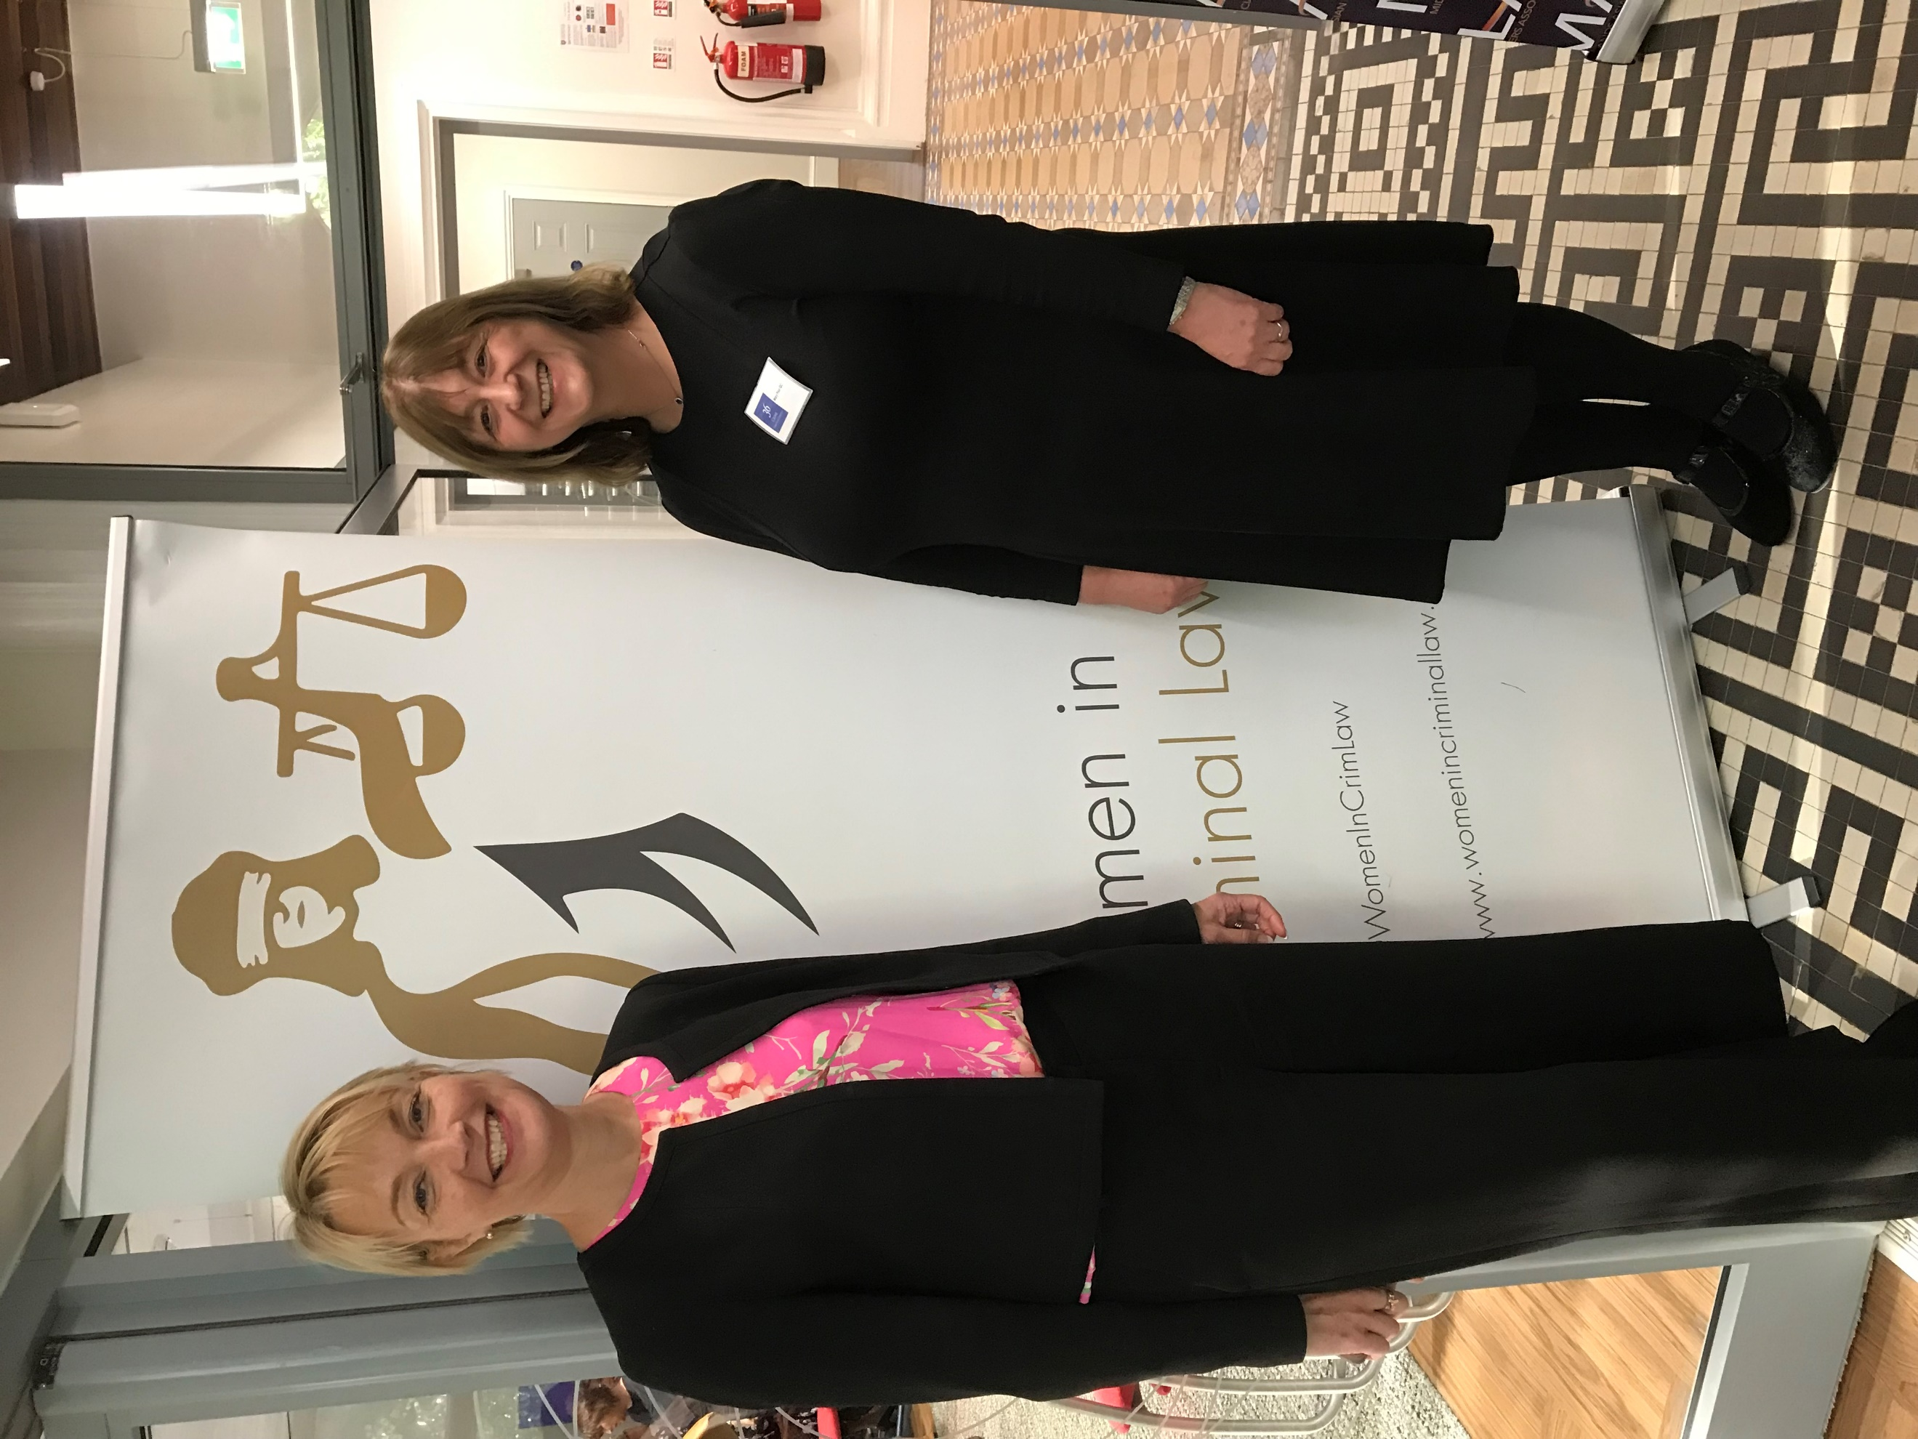

Helen Johnson (Emery Johnson Astills) and Mary Prior QC (the 36 Group)

Helen Johnson, committee member and founder of Emery Johnson Astill's Solicitors, Leicester said “WICL allows women working in all areas of the criminal justice system to come together and support one another acknowledging that aspects of the work are difficult and that our wellbeing is not something which can or should be overlooked. It was great to see a real mix of women in the room from a High Court Judge to law students just taking their first step in a career which has seen so many positive changes for women but where still more change is needed.”

Mary Prior QC a local practitioner said “There is so much talent in Leicestershire and the East Midlands. We need to support and encourage each other to succeed. WICL is designed to promote and inspire women to progress and remain within the profession. We were delighted that so many women attended today and that MALA and The36Group co-hosted this event.”

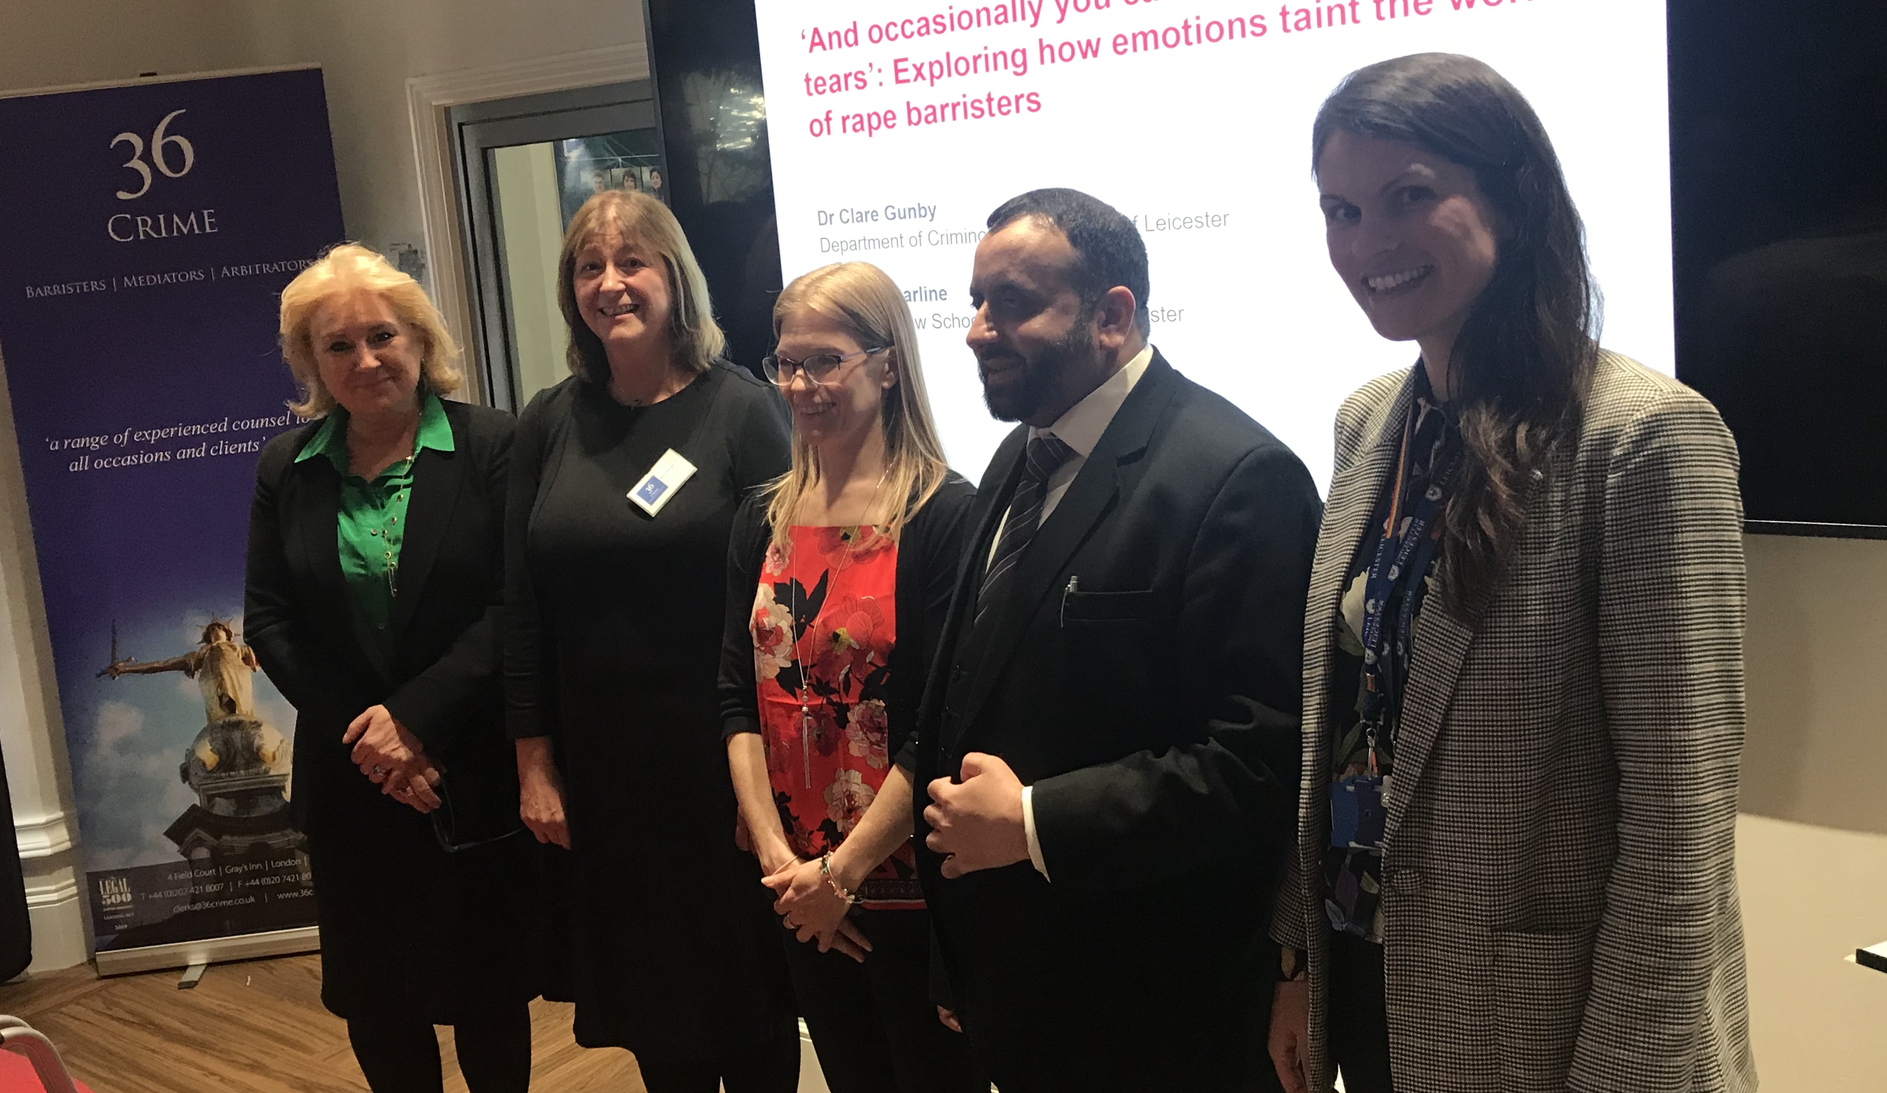 L To R - Mrs Justice Sue Carr DBE, Mary Prior QC, Dr Anna Carline, District Judge Fayyaz Afzal OBE, Dr Clare Gunby.

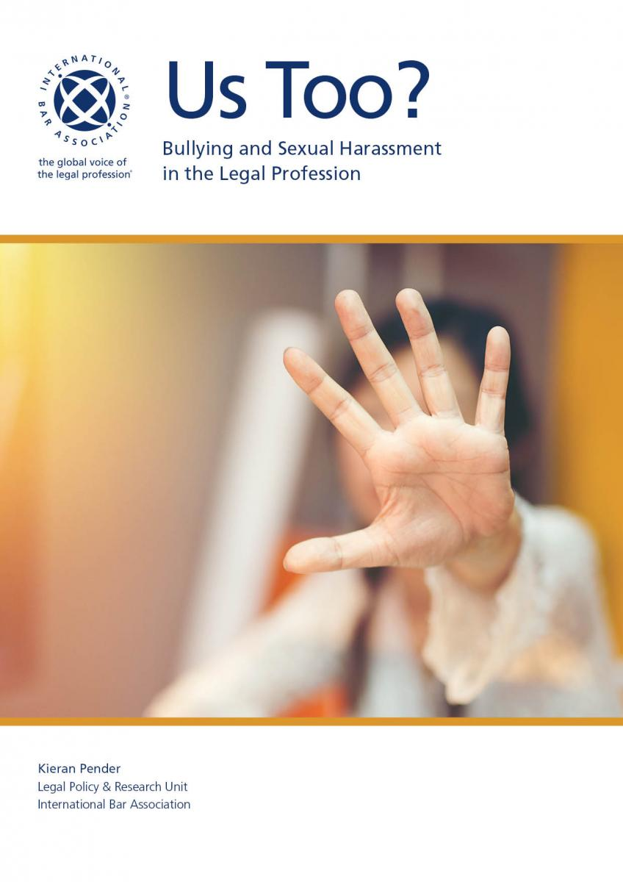

A new IBA report calls time on ‘endemic’ bullying

in the legal profession with empirical confirmation that bullying and sexual harassment are rife in the legal profession

In 2018, the International Bar Association (IBA) and Acritas conducted the largest-ever global survey on bullying and sexual harassment in the legal profession.  The results of this survey have now been released. You can [download a copy of the report here.](https://www.ibanet.org/bullying-and-sexual-harassment.aspx)

Nearly 7,000 individuals from 135 countries responded to the survey, from across the spectrum of legal workplaces: law firms, in-house, barristers’ chambers, government and the judiciary.

The results provide empirical confirmation that bullying and sexual harassment are rife in the legal profession.

* Approximately one in two female respondents and one in three male respondents had been bullied in connection with their employment.
* One in three female respondents had been sexually harassed in a workplace context, as had one in 14 male respondents.

This report provides a succinct analysis of that data, to raise awareness about the nature, extent and impact of the problem and inform the development of solutions.

On Wednesday 15th May 2019 the report launched at the event “Us Too? Bullying and Sexual Harassment in the Legal Profession” at law firm Herbert Smith Freehills LLP in London.

 Christina Blacklaws, president of the Law Society of England and Wales, said "Businesses, including law firms, should examine their workplace culture and procedures for dealing with complaints.

"Just as anyone is protected by the law, they should also be protected by employers."

Helena Kennedy QC at the launch

A group of people standing in front of a window

Description generated with high confidence

Helena Kennedy QC, director of the IBA’s Human Rights Institute, said "This is now the global legal profession listening to the voices of those who say we haven’t got it completely right.

"It is the start of something much bigger. We need to get this right."

*Farore Law – law firm report into progression of women in professions including law and judiciary in May 2019 – has some useful statistics*

<https://static1.squarespace.com/static/5c9b72ea0490796e32459415/t/5ce3fce88ca6ca0001662d9c/1558445351569/FL+Report+May+2019.pdf>



18th June 2019

Location

**[London](https://www.doughtystreet.co.uk/location/london)**

54 Doughty Street  
London  
WC1N 2LS  
020 7404 1313

Top of Form

**TUESDAY 18th JUNE**

**6.30pm (Registration from 6pm) - 8pm followed by drinks**

**53-54 Doughty Street, London, WC1N 2LS *(***[***click here***](https://www.google.com/maps?q=doughty+street+chambers+maps&rlz=1C1GCEB_enGB821GB821&um=1&ie=UTF-8&sa=X&ved=0ahUKEwjHorXm_sLiAhVVrHEKHTtGD3IQ_AUIDigB) ***for a map)***

On 18 December 1979 the United Nations General Assembly adopted the Convention on Elimination of All Forms of Discrimination against Women - CEDAW. Women throughout the world have reason to celebrate the existence of CEDAW. It provides a universal normative framework for the condemnation of discrimination against women and for the achievement of ‘the full development and advancement of women for the purpose of guaranteeing them the exercise and enjoyment of human rights and fundamental freedoms on a basis of equality with men’.

Through the work of its monitoring Committee, the Convention has transformed the understanding of sex and gender-based discrimination. This has been instrumental in bringing violence against women and girls onto the international agenda, which made governments accountable for the ways in that women are treated through national legal systems and practices and for their failure to exercise due diligence with respect to the acts of non-state actors. In March of this year, the Committee issued its concluding observations to the United Kingdom’s 8th report, with some commendations but also highlighting areas of concern. We might well ask: where would women be without CEDAW?

Doughty Street's [**Keina Yoshida**](https://www.doughtystreet.co.uk/barristers/keina-yoshida), an international human rights specialist, will moderate a conversation between two of the world's leading experts on CEDAW and the work of its monitoring committee, **Ms Nahla Haidar** and **Professor Christine Chinkin**.

**For a ticket please e-mail** [**events@doughtystreet.co.uk**](mailto:events@doughtystreet.co.uk)

*The event is co-hosted with the Feminist Law of Peace and Security Project at LSE's Centre for Women, Peace and Security, funded by the AHRC and British Academy.*

**Welcome -** [Caoilfhionn Gallagher QC](https://www.doughtystreet.co.uk/barristers/caoilfhionn-gallagher-qc)

**Moderator -**[Keina Yoshida](https://www.doughtystreet.co.uk/barristers/keina-yoshida)

Bottom of Form

***Why not join the Association of Women Judges?***

Our website is at [www.ukawj.org.uk](http://www.ukawj.org.uk) . On it you can download our membership form and see what is happening.

Membership is open to salaried and fee paid judges and to men and women.

This newsletter is edited by [HHJ.Sue.Williscroft@ejudiciary.net](mailto:HHJ.Sue.Williscroft@ejudiciary.net) – contact her if you have any news to share or events you would like to report on- or you want to be our “meet a member” person.