

**Newsletter January**

**2019**

**Contents**

* Talk by Jo Delaunty QC in Manchester on 4th February in the presence of the Senior President of Tribunals
* Regional meeting of the IAWJ is now in Madrid in April 2019 – book the date
* 1st 100 years – exhibition is available at the Supreme Court
* The AWJ Academic and Judge lecture series – launch at the Supreme Court on 21st March 2019
* Law Society conference ending the women in leadership in law year – book the dates
* Launch of Women in Criminal Law in the Midlands
* Women’s legal landmarks lecture series
* Lecture series in London jointly presented by St Marys University to celebrate centenary
* Western Circuit Women’s forum event
* Films “The Judge” and “Palais de Justice”
* Our Honorary Presidents lecture
* “On courage.”

Discussion for Judges – Monday 4th February at 5.30pm for 6.15 at Manchester Civil and Family Justice Centre 1 Bridge Street West Manchester M60 9DJ.

“As the words of the judicial oath make clear, the principles of equality and fair

treatment have always been fundamental to the role and conduct of the judiciary when carrying out their judicial functions. As all judges will recognize, these principles should also be reflected in conduct outside court.

We expect all judicial office-holders to treat everyone decently and with respect”.

The first two lines of a statement from the Lord Chief Justice and Senior President of Tribunals issued in September 2018 .

Members of the bar have reported and discussed sexual harassment and discrimination and abuse of power at work and in the courtroom -see the “Behind the Gown” initiative (www.behindthegown.com).

Judges are in a position of great power. We oversee the court process in which advocates and witnesses in the court process take part . Are we the best Judges of our own conduct? Would we recognise it if was raised? Can we ensure this kind of experience doesn’t happen, or is perceived to happen, in our courts?

And what of situations we may experience where dynamics behind the court room with colleague judges might impact on our confidence and career progression. Would support and mentoring for Judges as they progress up the career ladder be useful? If so how might that best work?

We plan to discuss experiences and ideas in a non- confrontational and collaborative way and to draw from that discussion constructive ideas for court room and career management.

The session will be attended by the Senior President of Tribunals and led by Jo Delahunty QC a barrister, Recorder and Professor of Law at Gresham College

It is for Judges only, and subject Chatham House Rules You can be a full or part time judge of any kind. You do not need to be a member of the Association of Women Judges

If you want to come you must register through Eventbrite using your judiciary e mail please ( to ease security) – the event is free.

[https://www.eventbrite.com/e/judges-discuss-the-judicial-oath-tickets-54533566365](https://emea01.safelinks.protection.outlook.com/?url=https%3A%2F%2Fwww.eventbrite.com%2Fe%2Fjudges-discuss-the-judicial-oath-tickets-54533566365%3Faff%3Dutm_source%253Deb_email%2526utm_medium%253Demail%2526utm_campaign%253Dnew_event_email%26utm_term%3Deventurl_text&data=02%7C01%7C%7C36dc421326af4c7b7d0708d677b59dd2%7C723e45572f1743ed9e71f1beb253e546%7C1%7C0%7C636828019254848585&sdata=eUkYdfrsjZQDeuRvpkZeZXUT1T0kIkeJIh4BE1%2FWXrE%3D&reserved=0)

Please note – we will be running this event also in London in May or June of this year

*21st March 2019 at the Supreme Court*

*Notice will be out shortly about this event which launches a year of lectures celebrating the role of women Judges and 100 years of women in law.*

*The launch event will feature three great women judges who have each been trailblazers in their own way ; Brenda Hale, Elizabeth Butler-Sloss and Teresa Doherty each introduced by a leading academic.*

*The series which follows will involve discussions between academics and judges about important legal topics. The first in the series will be on 8th May in Oxford with Dame Laura Cox and Professor Sandy Fredman.*

***The Estella Hindley QC bursary***

The sad death of our former secretary and committed member Her Honour Judge Estella Hindley QC last year led to us considering how to honour her memory and important role in our association. We shall continue to sponsor two women judges to attend the International Association of Women Judges biennial conference under her name as the Estella Hindley Bursary. Anyone who would like to contribute to these funds – You can do so by paying money directly into our account marked EH bursary – our account details are

|  |  |  |  |
| --- | --- | --- | --- |
| Bank | Sort Code: | A/c Name: | A/c No: |
| HSBC OSWESTRY | 40-35-32 | UNITED KINGDOM ASSOCIATION OF WOMEN JUDGES | 91674021 |

We know that this award will help women who otherwise would be unable to attend to have a unique experience to enhance their understanding of issues facing women judges throughout the world and benefit from the unique sense of working together , making new friends and ongoing support that this provides



**First 100 Years Art Exhibition**

Wednesday 2 January to Thursday 31 January 2019

Weekdays, 09:30 to 16:30 (last entry 16:00)

​

Visit this pop-up exhibition marking the centenary of the Sex Disqualification (removal) Act 1919, which is on show at the Supreme Court throughout January 2019. The exhibition, kindly on loan from the First 100 Years Project, will celebrate 100 years of women in law.

​

Admission free, no booking required.

Location in Supreme Court building: lobby on second floor.

**Merseyside – celebrating 100 years of women in law on 25th January 2019**

The event is in the Lodge, The Club House, Liverpool One and will run from 6pm

The event is being organised by Millie Hayden, currently chair of the Women Lawyers Division for Merseyside.

They are aiming to have a rolling history of the firms in the city and the women who have worked in them on a projector presentation on the night. The rest of the evening is a celebration with live music and food.



**Women in Criminal Law launches in the Midlands** – opening event at the Jury’s Inn in Nottingham on the 7th February 5.30 to 8.30 – no charge. You can rsvp or make enquires at [midlandswicl@gmail.com](mailto:midlandswicl@gmail.com)

*Free lecture series in London*

**Oliver Fisher Solicitors** and the **Centre for Law & Culture, St. Mary’s University**, present this free, informal, 6 part public lecture series to celebrate the centenary of the First Women Lawyers. Book through Eventbrite

www.eventbrite.co.uk/e/first-women-lawyers-centenary-celebration-tickets-54401738063

**January 25 (Friday) 2019 6-8pm:** Dr Mari Takayanagi ‘The passage of the **Sex Disqualification (Removal) Act 1919**’ and

Dr Caroline Morris ‘**Dr Ivy Williams**: First Woman to be called to the Bar of England and Wales’

**February 22 (Friday) 2019 6-8pm:** Dr Judith Bourne ‘**Helena Normanton**: First pioneer woman to make use of the Sex Disqualification (Removal) Act 1919’ and

Elizabeth Cruickshank ‘**Carrie Morrison**: First woman admitted as a solicitor in England and Wales’

**March 29 (Friday) 2019 6-8pm:** Dr Caroline Derry ‘**Monica Geike Cobb**: First woman to practise as a barrister in England and Wales’ and

Katie Broomfield ‘**Mary Sykes**: One of the first cohort of women solicitors’

**April 26 (Friday) 2019 6-8pm:** Ros Wright QC ‘**Sybil Campbell**: The first woman Judge in England and Wales’ and

Liz Goldthorpe J ‘**Averil Deverell**: The first woman lawyer (?)’

**May 31 (Friday) 2019 6-8pm:** Charlotte Coleman ‘**Auvergne Doherty**: First woman from the Empire (Western Australia) to be called to the Bar of England and Wales’ and

Dr Frances Burton ‘**Betty Archdale**: Called to the Bar at Gray’s Inn in 1938. Like Doherty, Archdale made her career in Australia’

**June 21 (Friday) 2019 6-8pm:** ‘100 Years on…’ Roundtable discussion with Partners and solicitors from our kind sponsors, Oliver Fisher Solicitors with **Dr. Laura Janes**, Legal Director and Solicitor at the Howard League for Penal Reform and **Caoilfhionn Gallagher QC**, Doughty Street Chambers.



**The International Association Regional Meeting** is to take place on April 25th and 26th this year in **Madrid** (moved recently from Seville) with the title “Justice from a gender perspective.” It will be free for members and there is likely to be a recommended hotel – final details are not available but will be e mailed to members once they are.



The organisers say, “The programme will be very complete, diverse and of high legal level.” A regional whatsapp group is active and suggests members from a number of different countries should be present – we are in the Europe and Middle East section.

[**Women's Legal Landmarks** Celebrating the history of Women and Law in the UK and Ireland](https://womenslegallandmarks.com/)

**Women’s Legal Landmarks ‘In Conversation’**

In the centenary year of women’s formal admission to the legal profession, the [Institute of Advanced Legal Studies](https://www.sas.ac.uk/institutes/institute-advanced-legal-studies) will host a series of talks –[Women Legal Landmarks – In Conversation](https://womenslegallandmarks.com/wp-content/uploads/2019/01/Women-Legal-Landmarks-–-In-Conversation.pdf) – exploring legal landmarks for women.

13 February 2019

* **Sex Discrimination Act 1975** *Anne Morris*
* **Sex Discrimination (Election Candidates) Act 2002** *Sue Atkins*

13 March 2019

* **First women’s refuge, 1971** *Felicity Kaganas*
* **First Rape Crisis Centre, 1976** *Alison Diduck*

10 April 2019

* ***A Brief Summary of the Most Important Laws Concerning Women*, Barbara Leigh Smith Bodichon, 1854** *Joanne Conaghan*
* **Greenham Common Women’s Peace Camp, 1981-2000** *Elizabeth Woodcraft*

15 May 2019

* **Health (Family Planning) Act 1979**   *Máiréad Enright*
* **Thirty-sixth Amendment to the Irish Constitution, 2018** *Fiona de Londras*

12 June 2019                      

* **Section 5(1) of the Criminal Law Amendment Act 1885** *Lois Bibbings*
* ***R* v *Jackson* (1891)** *Teresa Sutton*

11 September 2019

* **Match Women’s Strike, 1888** *Jacqueline Lane*
* **Dagenham car plant strike, 1968** *Dawn Watkins*

16 October 2019

* ***A Pageant of Great Women*, Cicely Hamilton, 1909-1912** *Katharine Cockin*
* ***DPP* v *Jonathan Cape and Leopold Hill* (1928)** *Caroline Derry*

13 November 2019

* **Married Women’s Property Act 1882** *Andy Hayward*
* **Married Women’s Property Act 1964** *Sharon Thompson*

11 December 2019

* **Sex Disqualification (Removal) Act 1919** *Mari Takayanagi*

Women’s Legal Landmarks at Manchester Law School

The Sylvia Pankhurst Gener and Diversity Research Centre hosts an afternoon discussion about the Project, the landmarks and feminist law reform. Speakers include Erika Rackley, Kay Lalor  Annapurna Waughray, Anne Morris, Nikki Godden-Rasul, Penny Russell and Ruth Lamont.

6 December 2-4pm, BR G.78 – Lecture Theatre 1, Brooks Building, Manchester Metropolitan University. More details [here](https://www.eventbrite.co.uk/e/womens-legal-landmarks-celebrating-the-history-of-women-and-law-tickets-51652696606).

**The Disappearance of Miss Bebb**

The Kalisher Trust Birmingham University and Law Society ran a conference with a range of fantastic speakers in October 2018 followed by this play put on by the Kalisher players – lively and interesting in the fantastic main hall of the University. It detailed the determined efforts made by Gwyneth Bebb to become a lawyer and the litigation she undertook unsuccessfully at the time to achieve this. A reminder of how much has changed in the last 100 years

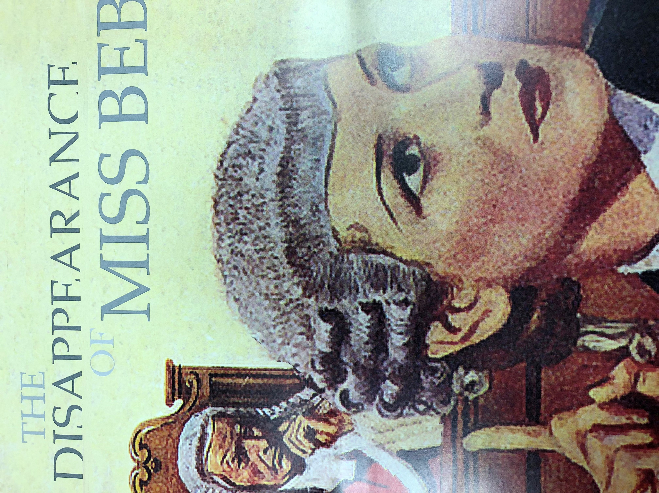

The Western Circuit Women’s Forum is hosting a conference on 8th March 2019 at Armada House, Telephone Avenue Bristol BS1 4BQ from 2 to 6 pm to celebrate international womens day entitled ‘Women in Law – Support, Retention and Progression’. We have a stellar line-up of inspirational speakers and it is promising to be a really good event.

To book – it’s free – contact cmashembo@magdalenchamberfs.co.uk

INTERNATIONAL SYMPOSIUM ON WOMEN IN LAW



This two day event on 20-21 June 2019 in London will celebrate the successes of women in law since 1919. Run by the Law Society it will look at the insights gained from the women who contributed to the “Women in Leadership in Law” roundtables and launch a final set of toolkits , reflecting on research about what works and how to achieve it.

To take part in or host a roundtable or get a copy of one of the toolkits contact lauren.thornton@lawsociety.org.uk

*Film – the Judge*

We are currently arranging local screening of this documentary film in Sheffield Birmingham and Glasgow – the idea being we will have a screening followed by a discussion. Those who were able to see it at the international conference said it was thought provoking.

“When she was a young lawyer, Kholoud Al-Faqih walked into the office of Palestine’s Chief Justice and announced she wanted to join the bench. He laughed at her. But just a few years later, Kholoud became the first woman judge to be appointed to the Middle East’s Shari’a (Islamic law) courts. THE JUDGE offers a unique portrait of Judge Kholoud—her brave journey as a lawyer, her tireless fight for justice for women, and her drop-in visits with clients, friends, and family. With unparalleled access to the courts, THE JUDGE presents an unfolding vérité legal drama, with rare insight into both Islamic law and gendered justice. In the process, the film illuminates some of the universal conflicts in the domestic life of Palestine—custody of children, divorce, abuse—while offering an unvarnished look at life for women and Shari’a.”

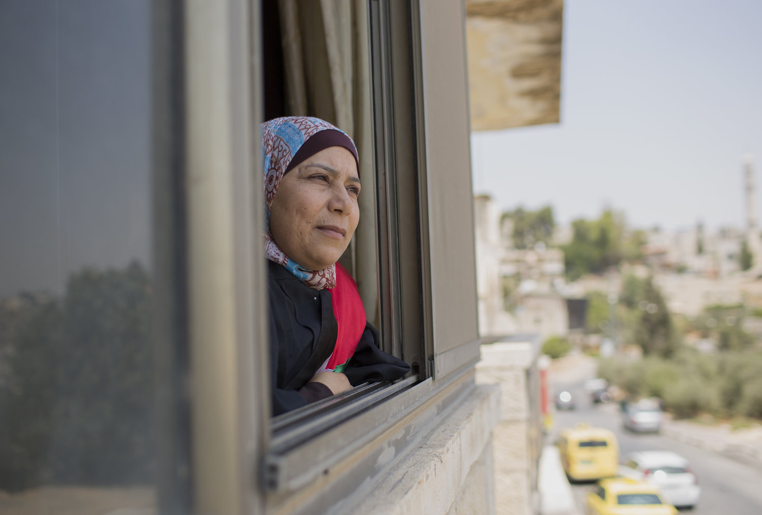

**In December 2018 the Millicent Fawcett memorial lecture** was given by the AWJ’s Honorary President Lady Hale

Titled ***“on courage”***

<https://www.supremecourt.uk/docs/speech-181213.pdf>

*Palais de Justice*

Artist Carey Young’s short film was presented at a joint seminar at the University of London hosted by Phillips Sands QC in December. I went to see it.

It was filmed in the extraordinary building in Brussels where many courts are based and features observations through windows of Judges and occasionally advocates at work. As the photograph below shows it has an enigmatic quality and the soundtrack of simply the muffled sounds of the courthouse adds to this.

She describes the courthouse as a “legal system seemingly centred on , and perhaps controlled by women.”

Described by one reviewer as “intriguing and moving” it was of necessity filmed outside the courts as she didn’t get permission to film inside. The reviews gave me an insight into a different world of artistic thought as incomprehensible in it’s language as our own. Carey herself says “ the concept of filming only female judges in dialectical relationship to the buildings innate patriarchal symbolism, then editing it into a sequence that would convey a kind of speculative-fictional proposition about women controlling the administration of justice came quickly and was based on real events; the preponderance of female judges repeatedly on view at the Palais.” See her website for a full article from her and related articles about this work

I think we should go and see this amazing building !

Exhibition of film at Feb 16 to June 2 at Towner Art Gallery, Eastbourne

Articles at  [https://www.tandfonline.com/eprint/r934rGMrP4U3wMRPFzU3/full#_i14](https://emea01.safelinks.protection.outlook.com/?url=https%3A%2F%2Fwww.tandfonline.com%2Feprint%2Fr934rGMrP4U3wMRPFzU3%2Ffull%23_i14&data=02%7C01%7CHHJ.Sue.Williscroft%40ejudiciary.net%7Cbffd6d3d792e4a9f0a7408d676549e03%7C723e45572f1743ed9e71f1beb253e546%7C1%7C1%7C636826504276341347&sdata=T8QkraAKy3uFe4NCQ9qnGaG4FfwSIZvgYLeCD7qByuQ%3D&reserved=0)

HHJ Sue Williscroft

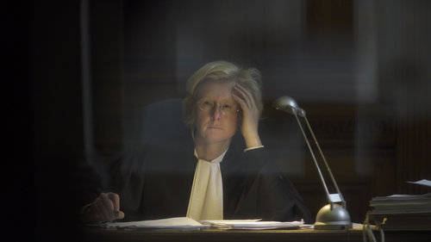

***Why not join the Association of Women Judges ?***

Our website is at [www.ukawj.org.uk](http://www.ukawj.org.uk) . On it you can download our membership form and see what is happening.

Membership is open to full and part time judges and to men and women.

This newsletter is edited by [HHJ.Sue.Williscroft@ejudiciary.net](mailto:HHJ.Sue.Williscroft@ejudiciary.net) – contact her if you have any news to share or events you would like to report on